  
  View online version

  March 2025
  TV Business Case Studies
  Inspiration from
  the egta Knowledge Hub
  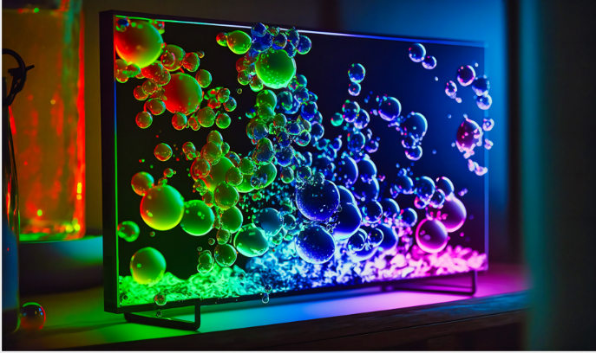

Discover the latest insights from our MIM conference last week!
In case you missed our annual Market Intelligence Meeting (MIM), don’t worry, we’ve got you covered! This month, we’re featuring two noteworthy presentations from our members. Explore one case from our audience measurement day and one from our research day, dive into the latest innovations in measurement from Austria, along with remarkable research insights from Italy!

  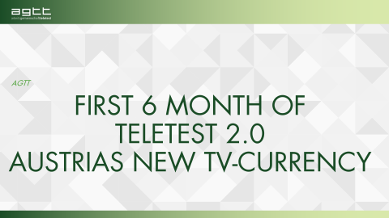
  Teletest 2.0: Austria’s Next-Gen TV Measurement
  Teletest 2.0 revolutionizes Austrian TV measurement by introducing a synthetic panel of 100,000 participants, real-time data collection, and enhanced ad reach accuracy. The system eliminates zero ratings, stabilizes video reach, and improves audience visibility, especially for younger demographics. It enables data-driven programming and optimizes ad placements through TV-LOAD, reducing ad reach variability by 86%. Advertisers benefit from dynamic commercial break adjustments, maximizing engagement and ROI. By integrating digital advertising models, Teletest 2.0 strengthens TV’s competitiveness in the evolving media landscape, ensuring sustainable growth and improved profitability for broadcasters and advertisers.
  > DISCOVER NOW
  
  The Streamcasting Challenge and the Battle for Ad-Tention
  The study “The Streamcasting Challenge and the Battle for Ad-Tention” reveals that audience attention shifts between editorial content and advertising, forming an "attention parabola." Editorial content attracts focused attention, while ads often see a drop unless engaging. Linear TV shows the strongest link between content engagement and ad recall. Strategic ad placement in high-attention content enhances effectiveness, and creative storytelling sustains engagement. TV and Broadcaster VOD drive stronger brand awareness than streaming. Advertisers should optimize ad timing, tailor content for engagement, and use data-driven insights to maximize impact across platforms in an increasingly fragmented media landscape.
  > DISCOVER NOW

egta members can download more MIM slide decks:

  > TV day 1 (Measurement Session)
  > TV day 2 (Research Session)

Stay caught up - NEW: AUDIENCE MEASUREMENT reports

> Advances in Multiplatorm TV

